Dear Athletic Director/Head Track & Field Coach:

**2021 PIKES PEAK ATHLETIC CONFERENCE**

**TRACK & FIELD CHAMPIONSHIPS**

We would like to invite you to the **2021 Pikes Peak Athletic Conference Championship** meet. This meet will take place at Fountain-Fort Carson High School (Guy. R. Barickman Stadium) on **June 3-4, 2021**. This is a state qualifying meet and results will be posted on Colorado Mile Split.

**THURSDAY START TIME:** 9:00 am (see events schedule) – Coaches Meeting at 8:30 am at the Trojan Field House

**FRIDAY START TIME:** 9:00 am (see events schedule) – Coaches Meeting at 8:30 am at the Trojan Field House

**ENTRY FEE:** $300 (includes boys and girls teams)

**TEAM TROPHIES**: 1st, 2nd, and 3rd places

**AWARDS:** 1st, 2nd and 3rd place individual medals

**EXCELLENCE AWARDS:** Top male/female track athletes and field athletes of the meet.

**RULES**: CHSAA rules will be observed. Spikes no longer than 3/16’ of an inch.

**TIMING/RESULTS:** Jim Chapman ([j_chapma71@yahoo.com](mailto:j_chapma71@yahoo.com))

**TEAMS:** PPAC teams only.

**ENTRIES:** 4 entries per event, per team. Add event entries through co.milesplit.com. Deadline is Wednesday, June 2. Heat sheets will be posted on Mile Split by 7 am on Thursday, June 3, 2021.

**RETURN TO**: Jared Felice, District/High School Athletic Director

Fountain-Fort Carson High School/900 Jimmy Camp Road/Fountain, Colorado 80817

Phone: 719-382-1649/ Fax: 719-382-3228/ Email: [jfelice@ffc8.org](mailto:jfelice@ffc8.org)

**LOGISTICAL ITEMS AND SERVICES:**

* Athletes must report to the check-in area at the first call, prior to the event, at the Trojan Field House.
* No coaches or athletes will be allowed on the infield during the meet unless they are warming up or competing for the next event in the warm up area.
* An athletic trainer will be available for the treatment of injuries.
* Awards will be placed in an envelope for the coach to pick up at the end of the day on Friday in the press box.
* Tents may only be set up on the top row of bleachers.
* Concessions will not be available during the meet.

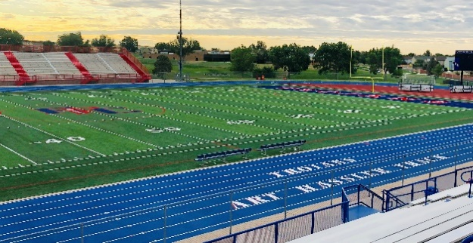



**2021 PPAC TRACK & FIELD CHAMPIONSHIPS**

**\*All events begin with girls first, followed by boys on a rolling schedule\***

**Thursday Coaches meeting at 8:30 am at the Trojan Field House**

**9:00 am 3200m Run Fast Section Final**

**9:30 100m Hurdle Prelims**

**9:55 110m Hurdle Prelims**

**10:20 100m Dash Prelims**

**10:50 200m Dash Prelims**

**Lunch Break**

**11:50 300m Hurdle Final**

**12:00 pm 400m Dash Final**

**Friday *All Events are Finals – Coaches Meeting at 8:30 am at the Trojan Field House**

**9:00 am Sprint Medley Relay (girls only 100-100-200-400)**

**9:20 4 X 800m Relay**

**9:55 100m Hurdles**

**10:00 110m Hurdles**

**10:05 100m Dash**

**10:10 4 X 200m Relay**

**10:15 1600m Run**

**Lunch Break**

**12:00 pm 4 X 100m Relay**

**12:30 800m Run**

**1:05 200m Dash**

**1:15 3200m Run Slow Section**

**1:50 4 X 400m Relay**

**2:30 Awards Presentation**

**FIELD EVENTS**

**Thursday - 9:00 am Friday - 9:00 am**

**Boys High Jump Girls High Jump**

**Boys Long Jump Boys Triple Jump**

**Girls Long Jump Girls Triple Jump**

**Boys Shot Put Girls Shot Put**

**Girls Discus Boys Discus**

**\*Rampart High School is hosting the pole vault events\***

**Event Worker Assignments:**

Gate and Security:

* Fountain-Fort Carson

Long Jump and Triple Jump (3 from each school):

* Liberty (Boys)
* Cheyenne Mt (Girls)

High Jump (3 workers, boys’ and girls’ events):

* Doherty

Shot and Disc (3 from each school):

* Air Academy (Boys)
* DCC (Girls)

Pole Vault (3 workers; at Rampart HS):

* Rampart

Hurdle Crew (2 from each school, boys’ and girls’ events):

* Lewis-Palmer
* Palmer Ridge
* Pine Creek