Dear Athletic Director/Head Track & Field Coach:

**2021 Fountain-Fort Carson Track & Field Invitational**

***“Tradition Never Graduates”***

We would like to invite you to the **2021 Fountain-Fort Carson High School Varsity Boys’ and Girls’ Track & Field Invitational** meet. This meet will take place at Fountain-Fort Carson High School (Guy. R. Barickman Stadium) on **May 21-22, 2021**. This is a state qualifying meet and results will be posted on Colorado Mile Split.

**FRIDAY START TIME:** 3:30 pm (see events schedule) – Coaches Meeting at 3:00 pm at the Trojan Field House

**SATURDAY START TIME:** 9:00 am (see events schedule) – Coaches Meeting at 8:30 am at the Trojan Field House

**ENTRY FEE:** $300 for both teams; $175 for one team (see meet contract)

**TEAM TROPHIES**: 1st, 2nd, and 3rd places

**AWARDS:** 1st, 2nd and 3rd place individual medals

**EXCELLENCE AWARDS:** Top male/female track athletes and field athletes of the meet.

**RULES**: CHSAA rules will be observed. Spikes no longer than 3/16’ of an inch.

**TIMING/RESULTS:** Jim Chapman ([j_chapma71@yahoo.com](mailto:j_chapma71@yahoo.com))

**TEAMS:** 20 total teams will be invited. Please return the 3rd page of this invite to FFC Athletic Director, Jared Felice at [jfelice@ffc8.org](mailto:jfelice@ffc8.org)

**ENTRIES:** Add event entries through co.milesplit.com. Deadline is Wednesday, May 19th. Heat sheets will be posted on Mile Split by 7 am on Friday, May 21, 2021.

**RETURN TO**: Jared Felice, District/High School Athletic Director

Fountain-Fort Carson High School/900 Jimmy Camp Road/Fountain, Colorado 80817

Phone: 719-382-1649/ Fax: 719-382-3228/ Email: [jfelice@ffc8.org](mailto:jfelice@ffc8.org)

**LOGISTICAL ITEMS AND SERVICES:**

* Athletes must report to the check-in area at the first call, prior to the event, at the Trojan Field House.
* No coaches or athletes will be allowed on the infield during the meet unless they are warming up or competing for the next event in the warm up area.
* An athletic trainer will be available for the treatment of injuries.
* Awards will be placed in an envelope for the coach to pick up at the end of the day on Saturday in the press box.
* Tents may only be set up on the top row of bleachers.
* Concessions will not be available during the meet.

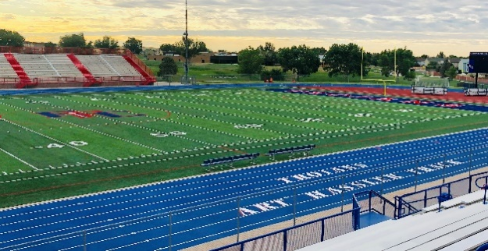



**2021 Fountain-Fort Carson Track & Field Invitational**

**\*All events begin with girls first, followed by boys on a rolling schedule\***

**\*Heat winners and the next 3 best times advance to the finals\***

**Friday Coaches meeting at 3:00 pm at the Trojan Field House**

**3:30 pm 100m Hurdle Prelims**

**3:55 110m Hurdle Prelims**

**4:20 100m Dash Prelims**

**5:00 400m Dash Prelims**

**5:45 300m Hurdle Prelims**

**6:30 200m Dash Prelims**

**7:15 3200m Run Fast Sections Final**

**Saturday *All Events are Finals – Coaches Meeting at 8:30 am at the Trojan Field House**

**9:00 am Sprint Medley Relay (girls only 100-100-200-400)**

**9:20 4 X 800m Relay**

**9:55 100m Hurdles**

**10:00 110m Hurdles**

**10:05 100m Dash**

**10:10 4 X 200m Relay**

**10:15 1600m Run**

**Lunch Break**

**12:00 4 X 100m Relay**

**12:30 400m Dash**

**12:40 300m Hurdles**

**12:50 800m Run**

**1:25 200m Dash**

**1:30 320m Run Slow Section Final**

**2:10 4 X 400m Relay**

**2:30 Awards Presentation**

**FIELD EVENTS**

**Friday 3:30 pm Saturday 9:00 am**

**Boys High Jump Girls High Jump**

**Boys Long Jump Boys Triple Jump**

**Girls Long Jump Girls Triple Jump**

**Boys Shot Put Girls Shot Put**

**Girls Discus Boys Discus**



**2021 Fountain-Fort Carson Track & Field Invitational**

**May 21-22, 2021**

School: ______________________________

Athletic Director: _______________________________

Coach: _________________________________________

Coach E-mail: ______________________________ _____ Phone: ___________________

□ Both varsity boys and girls will compete - $300

□ Only boys will compete - $175

□ Only girls will compete - $175

*Make checks payable to:

Fountain-Fort Carson High School Athletics

900 Jimmy Camp Road

Fountain, CO 80817

***Teams willing to provide a competent adult worker for a field event may subtract $50 from entry fee***